**Introduction to Git Hub.**

1. Install the Git
2. Clone the repository

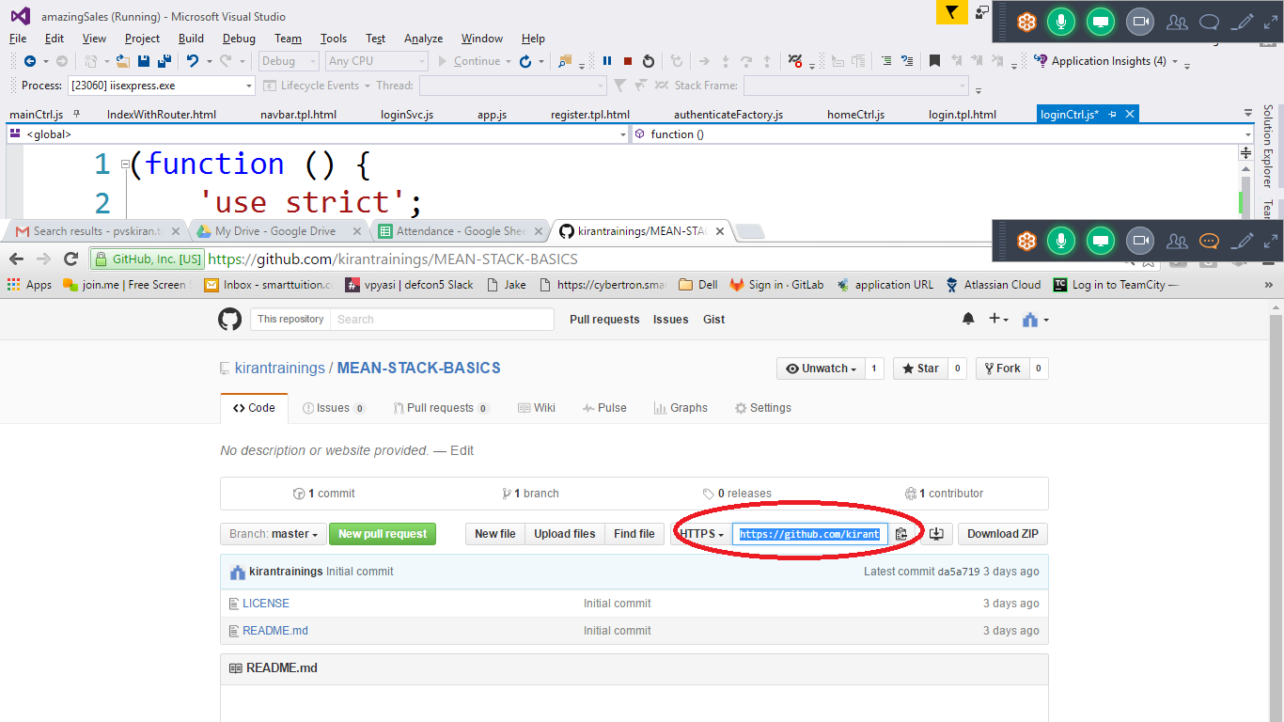

3.Select the the URL highlighted

1. Cloning open A folder and right click so that you find an option called gitbash here

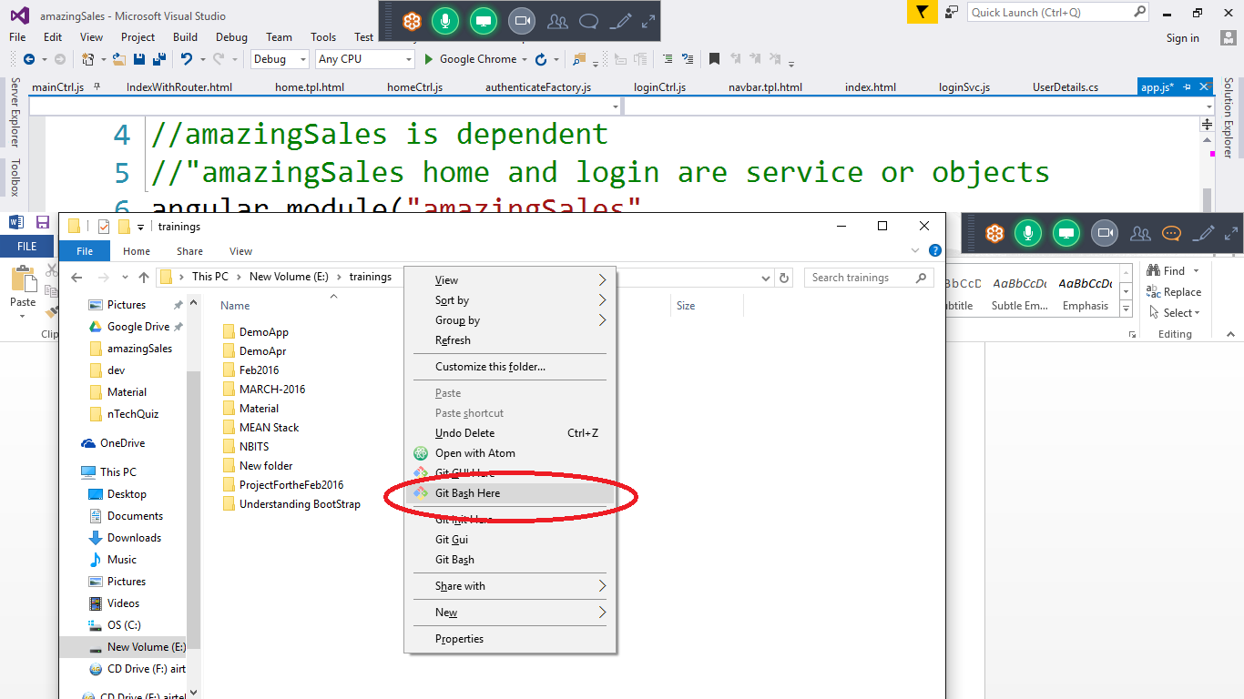

5. This will open a terminal and now enter the following command in side the command prompt

git clone <copied url>

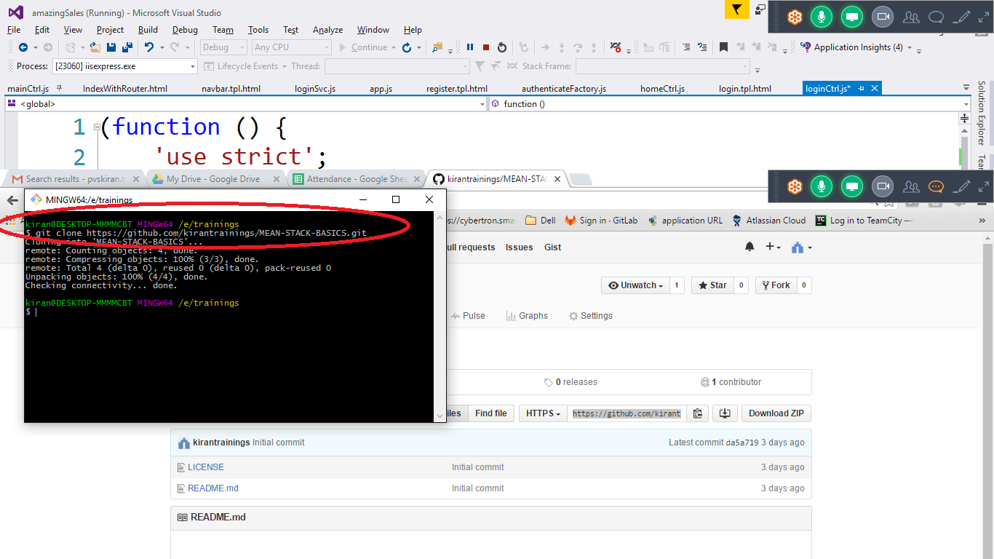

1. Open the cloned folder and again do the git bash on that folder you can use command prompt
2. Add your changes to the files on the folder
3. Command: git status

This command will show you the list of files that are changed or added.

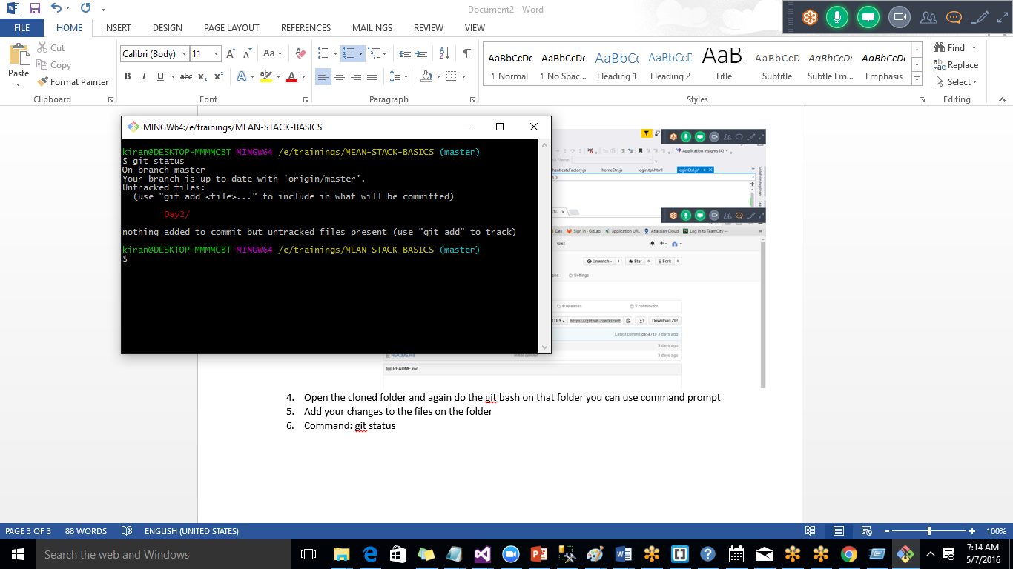

Command: git add –all

This will add all the changes to commit

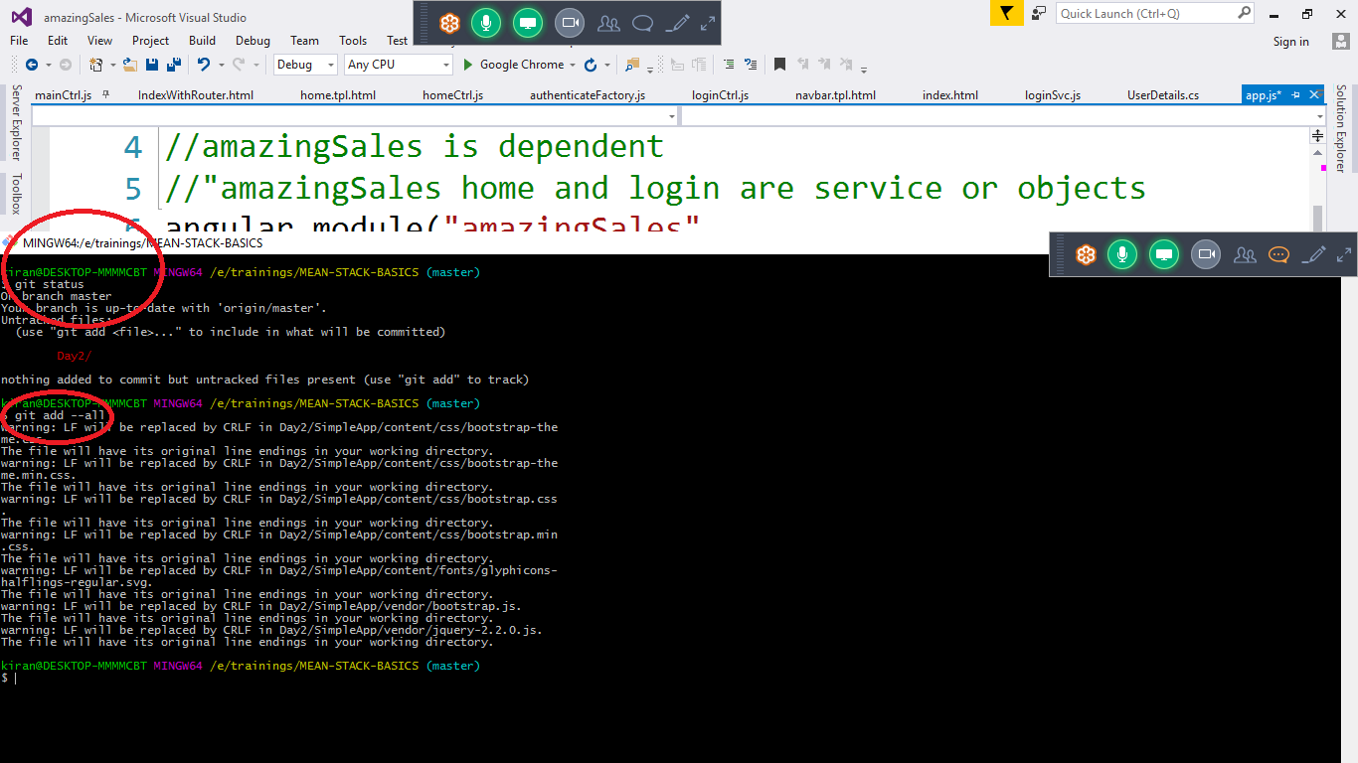

Command: git commit –m “Enter the message about the changes you made”

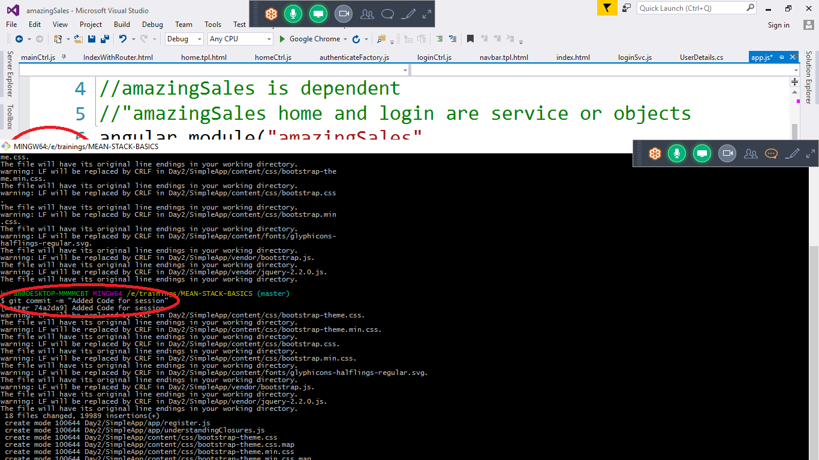

We need to push the local code the server.

Note: Before doing the push make sure you get the latest code from the git.

Git pull this will give the latest code from the server and then you need to merge your changes to the latest code. If you got the below error that means some else had pushed the code to the repository. So we need to take their code and merge with our code. Once that is done we need to push total code the server.

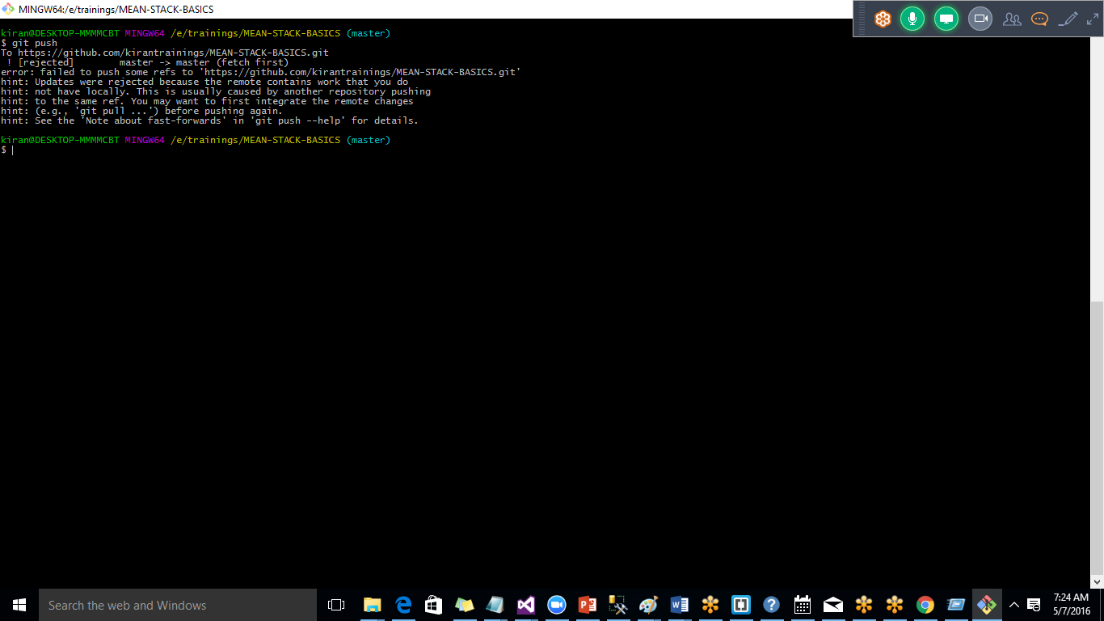

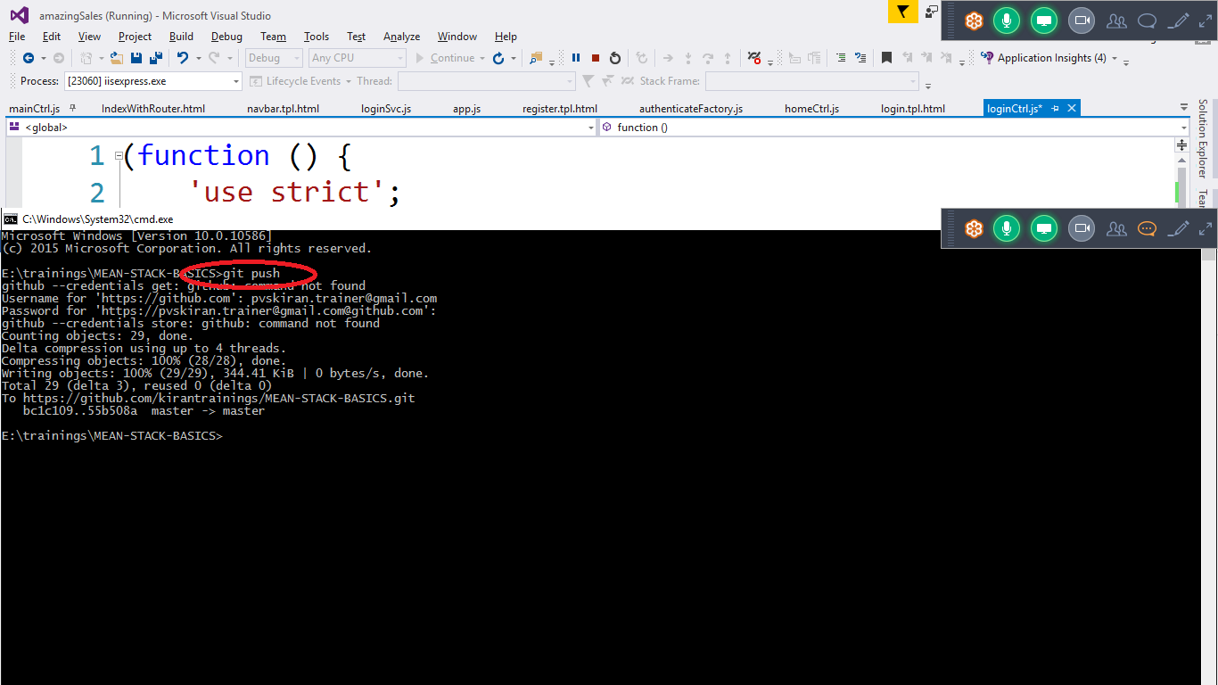

Latest code will be pushed to the reposiorty.